**ASSIGNMENT 1 FRONT SHEET**

|  |  |  |  |
| --- | --- | --- | --- |
| **Qualification** | **BTEC Level 5 HND Diploma in Computing** | | |
| **Unit number and title** | Unit 06: Managing a Successful Computing Project | | |
| **Submission date** | Thursday, 5 December 2019, 11:59 PM | **Date Received 1st submission** | Thursday, 5 December 2019, 11:59 PM |
| **Re-submission Date** |  | **Date Received 2nd submission** |  |
| **Student Name** | Pham Van Minh Duc | **Student ID** | GCD17053 |
| **Class** | GCD0703 | **Assessor name** | Srikanth Raju Kandukuri |
| **Student declaration**  I certify that the assignment submission is entirely my own work and I fully understand the consequences of plagiarism. I understand that making a false declaration is a form of malpractice. | | | |
|  |  | **Student’s signature** |  |

**Grading grid**

|  |  |  |  |  |  |  |
| --- | --- | --- | --- | --- | --- | --- |
| P1 | P2 | P3 | P4 | M1 | M2 | D1 |
|  |  |  |  |  |  |  |

|  |  |  |
| --- | --- | --- |
| **❒ Summative Feedback: ❒ Resubmission Feedback:** | | |
| **Grade:** | **Assessor Signature:** | **Date:** |
| **IV Signature:** | | |

# Table of Contents

Table of Contents 4

Table of Figures 6

Table of Table 7

Introduction 8

P1. Devise project aims and objectives for a chosen scenario. 9

I. Regulations in the project 9

II. Introduction 15

III. Project aims 16

IV. Objectives of the project 16

P2 and M1. Produce a project management plan covering aspects of cost, scope, time, quality, communication, risk and resources. 17

I. Project management plan 17

1. Estimated progress of the project 17

2. Control the project schedule 17

II. Cost for the project 18

1. Project cost for human resources 18

2. Other components when asking for costs in a project 19

3. Cost management plan of the project 19

4. Risk management in the project 20

4.1. Risk matrix in the project 20

4.2. Risk management plan in the project 22

P3 and D1. Produce a work breakdown structure and a Gantt Chart to provide timeframes and stages for completion. 23

I. Use the Agile method to implement the project 23

II. Project scope 24

III. List of completed milestones in the project 25

IV. Project communication management 28

1. Matrix of communication in the project 28

2. Structure in the project team 30

2.1 Developer group 30

2.2 Project research team 31

V. Project completion schedule and structures to be able to split up the work within the project 33

1. Work breakdown structure (WBS) 33

2. Progress in the project 33

2.1. Research and deployment stages 33

2.2. Construction phase and project development 34

2.3 Product stage and system maintenance 35

P4 and M2 Carry out small-scale research by applying qualitative and quantitative research methods appropriate for meeting project aims and objectives 36

I. Research quality in the project 36

II. Quantitative research in the project 37

Bibliography 43

# Table of Figures

Figure 1 Project Management 8

Figure 2 Work breakdown structure (WBS) 33

Figure 3 Research and planning in the project 34

Figure 4 Construction phase and project development 34

Figure 5 Product stage and system maintenance 35

Figure 6 User survey form table 38

Figure 7 User survey form table 39

Figure 8 The chart calculates the percentage of ages participating in the survey 40

Figure 9 Column chart calculates user satisfaction when using the application 40

Figure 10 Customer satisfaction level 41

Figure 11 User comments to be able to add additional utility functions of the application 41

# Table of Table

Table 1 Regulations in the project 15

Table 2 Project cost for human resources 19

Table 3 Other components when asking for costs in a project 19

Table 4 Risk matrix in the project 21

Table 5 Project tasks 27

Table 6 Matrix of communication in the project 29

Table 7 Developer group 30

Table 8 Project research team 32

# Introduction

To ensure that all customer expectations are met and the requirements, deadlines and all costs are estimated, work will be provided to all computer systems or new services for business organizations or can refurbish all existing projects as well as it will always be organized on all projects. Therefore, project managers are always very skillful as well as knowledgeable and have all the experiences to be able to manage projects most successfully.

The sole purpose of project management is to always provide all students and future project managers the opportunity to develop all the skills they need. This is the best way to manage and implement the project in the best way. In addition, after future project managers complete it will also help us to be confident in participating in all activities as well as being able to make decisions, and solve them all issues in the project.

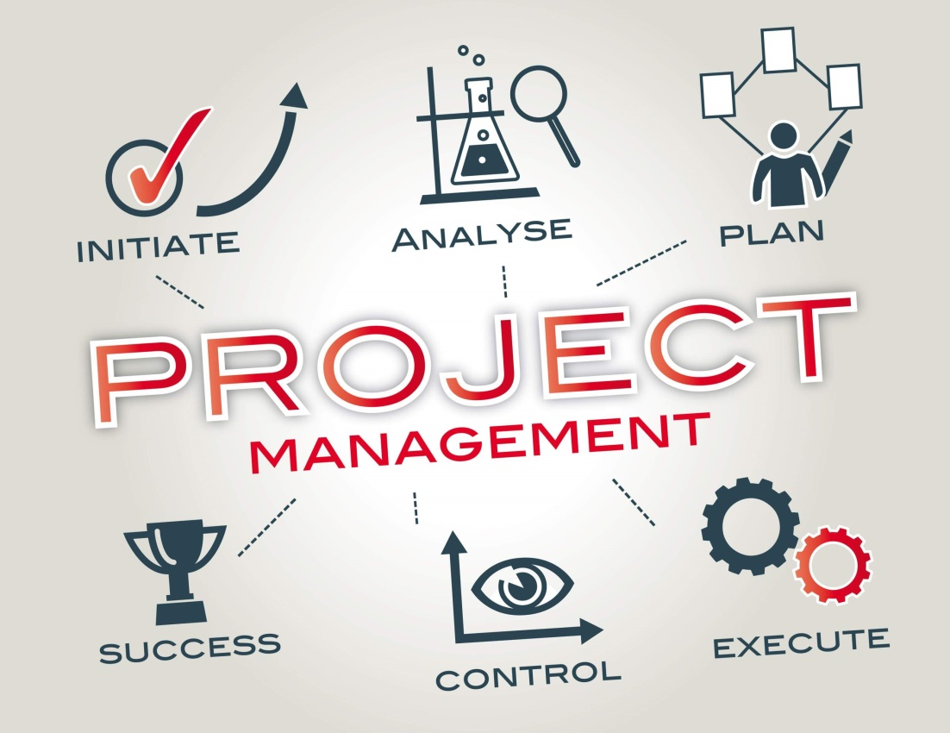

Figure 1 Project Management

(Baker)

## P1. Devise project aims and objectives for a chosen scenario.

### I. Regulations in the project

|  |  |  |  |  |  |
| --- | --- | --- | --- | --- | --- |
| 1. General information in the project | | | | | |
| Project Name: | | **Digital Wellbeing** | | | |
| Project operator sponsor: | | Chief Technology Officer – Microsoft. | | | |
| Main sponsor of the project: | | Upgrade the company's application system to a new product version and better quality than the old version. | | | |
| The great impact of the project: | | Upgrade the company's Digital Wellbeing application to an uniquely developed application. | | | |
| 2. Project team | | | | | |
|  | | **Full Name** | **The department responsible for the project** | **Phone Number** | **E-mail** |
| Project management team leader: | | Pham Van Minh Duc | Responsible for the entire project including all parts of the project | 070-888-8888 | minhduc@gmail.com |
| Project group: | | Edda Grissom | Research as well as project development | (557) 378-7177 | edd@gmail.com |
| Trent Atherton | Research as well as project development | (980) 427-6150 | trent@gmail.com |
| Jesusa Cardwell | Research as well as project development | (792) 318-4429 | jesusa@gmail.com |
| Jeramy Reddick | Research as well as project development | (340) 981-8496 | jera@gmail.com |
| Beryl Goetz | Research as well as project development | (457) 349-5518 | beryl@gmail.com |
| Wava Burdette | Research as well as project development | (253) 976-0925 | wava@gmail.com |
| Marinda Taber | Research as well as project development | (753) 253-6242 | marinda@gmail.com |
| Otto Dodson | Research as well as project development | (774) 502-3175 | otto@gmail.com |
| Moon Ricker | Research as well as project development | (216) 249-0855 | moon@gmail.com |
| Brooks Mueller | Customer care department | (743) 612-6596 | brook@gmail.com |
| Somer Brubaker | Customer care department | (822) 498-6448 | some@gmail.com |
| Maurita Browder | Customer care department | (738) 439-7727 | maurita@gmail.com |
| Tanika Munson | Customer care department | (534) 631-0799 | tanika@gmail.com |
| Isidro Pickering | Customer care department | (891) 407-8671 | isidro@gmail.com |
| Lilliam Cooley | Customer care department | (963) 636-8704 | lilliam@gmail.com |
| Jovita Brannon | Customer care department | (930) 298-5478 | jovita@gmail.com |
| 3. Stakeholders (e.g., those with a significant interest in or who will be significantly affected by this project) | | | | | |
|  | 1. Sundar Pichai– CEO of Google | | | | |
| 2. Ignacio Silva - Head of corporate recruiting company of Google | | | | |
| 3. Minnie Graham – Google Customer Service Manager | | | | |
| 4. Rogelio Bryant from the US - The world's leading application expert | | | | |
| 4. Project Scope Statement | | | | | |
| Purpose of the project / justification in business | | | | | |
|  | The development of the project: Digital Wellbeing has the sole purpose of helping users know how much time you spend on each application on your computer. In addition, it will be easy to improve for those who often only on Facebook, YouTube, online games, ... and do not have time for their current life. They can set a timer for each app and when the reservation time is up, the app icon will change color. | | | | |
| Objective (on the business side of the project) | | | | | |
|  | * Runs on all Android devices * Visualize the use of devices in the application * Visualize the use of devices in the system application * Visualize the time spent using the devices * Notification mode when the device is used in excess of the prescribed level * Visualize the ways to unlock the device * Visualize the session time of the device * Notice summarizes the equipment used during the day * Choose a dark theme in the application | | | | |
| Product handover in the project | | | | | |
|  | * Customizable capabilities of the device * Visualize the maximum usage of the average weekly devices * Device history is not limited by device memory * Allows users the option to back up device memory manually * See daily information about your digital routine: How often you use different applications, the number of notifications you receive, and how often you check your phone * Disconnect from your phone when you want: The daily app timer allows you to set limits on how long you can use the app, and the Sleep feature reminds you to turn off your phone at night, set a brightness adjustment schedule the screen is grayed out, while the Do Not Disturb mode turns off notifications to help you sleep soundly. | | | | |
| Scope of the project | | | | | |
|  | The purpose of the project includes: helping users know how much time you spent on each application on the day. Therefore, you can restrict or adjust the use to protect your health; Digital Wellbeing System is an easy device management system solution. In addition, it will be easy to improve for those who regularly only on Facebook, YouTube, online games, ... and no time for life to take place. The system will have a great virtual assistant application and give users to manage their devices as easily as the features include:   * Managing misuse of equipment. * Check the data status of the system as well as reduce the life of the device when used too often * Report the status of the current device. * Status report, you access a regular application * Security of the system and user information. * Manage device's access via alarm and timer system. | | | | |
| Milestones in the project | | | | | |
|  | * The planning stage as well as the project ideas in the project, identifying project members and project stakeholders. * Starting: November 18, 2019. * Ending: December 30, 2019 * Status: The status has been completed. * Planning stage in development, the cost in line with the project, project duration, research of all risk cases, quantitative, and qualitative research, identification of all technologies, recognition know the types of risks * Starting: December 31, 2019 * Ending: February 29, 2020 * Status: In progress * Development stage and system construction. * Starting: March 1, 2020 * Ended: May 1, 2020 * Status: Awaiting execution * The stage of delivery of product delivery and the maintenance of the system. * Starting: May 2, 2020 * Ended: June 25, 2020 * Status: Awaiting execution | | | | |
| Known major forms of risk (including all important risk assumptions) | | | | | |
|  | |  |  |  |  | | --- | --- | --- | --- | | **Risk** | **Status (High, Medium, Low)** | **Action** | **Responsible person** | | Lack of stakeholder participation in the project. | **High** | Contact back to the stakeholders to participate in the project. | Minh Duc - Project leader | | Project cost is not enough to continue. | **High** | Review project reports, fully check all project receipts, review all project members, and check that all project stakeholders have provided all project costs are not. | Minh Duc - Project leader | | Participants in the project participated not enough. | **Medium** | Recruit more staff for the project | Brooks Mueller - head of staff recruitment | | Some members of the project do not have professional knowledge. | **High** | Retrain staff or dismissal | Isidro Pickering | | Project members do not unite to implement the project. | **High** | Check the members' incidents during the process and find out why the members are not united. | Minh Duc - Project leader | | The project faces many high risks including: storms cause projects to be delayed, fire the company, Customers are not happy about the project ... | **Low** | Predict the risks and report back to the project team | Microsoft company. | | The project is delayed too expected. | **High** | Handover and complete the project within 3 days from the date of delay | Minh Duc - Project leader | | | | | |
| Constraints in the project | | | | | |
|  | * System management capabilities. * Ensuring security features and preventing unauthorized access cases. * Ensuring easy management features. * Ensure the application features can automatically write reports when using the device too often. * Ensure that Digital Wellbeing features prevent users from being overused on the device. * Ensure Digital Wellbeing can manage the device and also have daily reports after users finish using their devices. * Ensure that Digital Wellbeing can provide preventive measures and solutions to improve device abuse. | | | | |
| Depends on the impact of the project | | | | | |
|  | To achieve the success of Digital Wellbeing project it always depends on the coordination among all project groups including:   * The Digital Wellbeing project development team * Recruitment Department * Customer care department * Stakeholders in the project and Google company | | | | |
| 5. Strategy in project development communication | | | | | |
|  | **Methods of communication in the project:**   * Update all progress reports on the project to the Executive Sponsors every 3 weeks * Regular meetings take place including all project members and stakeholders in the project and each month and there will be unexpected meetings when the project has been successful in a pillar.   **The frequency for reporting statuses in the project:**   * Each project team member will appoint one person and take turns to be able to write the permanent reports and will be responsible for documenting the project and reporting back every week. | | | | |
| 6. Sign-off | | | | | |
| |  |  |  |  | | --- | --- | --- | --- | |  | **Full Name** | **Signature** | **Date (MM/DD/YYY Y)** | | **Executive Sponsor** | Sundar Pichai |  | 18/11/2019 | | **Department Sponsor** | larry page |  | 18/11/2019 | | **Project leader** | Minh Duc |  | 18/11/2019 | | | | | | |
| 7. Notes | | | | | |
|  | **N/A** | | | | |

Table 1 Regulations in the project

### II. Introduction

Google is one of the leading technology companies that has succeeded in the field of technology and has been able to build a solid reputation to become a leading technology company as well as around the world. In the world of the most reliable technology, Google has provided all the best personal services as well as superior quality technologies to all customers around the world.

In addition, Google has over 21 years of experience in the most advanced and unique technologies worldwide, now with the ability to develop and expand on AI technology as well as interest in users, Google believes. that developing new technology as a project: Digital Wellbeing will be able to assist a lot in caring for its users. Not only that, but Google has allowed our project team to develop and provide all the solutions in the interest of Google users.

### III. Project aims

* **Project:** Digital Wellbeing provides:
* Report the status of the current device.
* Status report, you access a regular application
* Security of the system and user information.
* Manage device access via alarm system and timer.
* View daily information about your digital routine: How often you use different applications, the number of notifications you receive and how often you check your phone
* Disconnect from your phone when you want: Daily app timer allows you to set a limit on how long you can use the app and the Sleep feature reminds you to turn off your phone at night, set a schedule adjust the screen brightness to be grayed out in addition, while Do Not Disturb mode will turn off notifications to help you sleep soundly.
* Digital Wellbeing can completely automate all the tasks assigned in the data as well as reduce user access (abusing too many phones).

### IV. Objectives of the project

When developing the Digital Wellbeing project and developing this project can meet all the goals of the following project:

* Easy system management.
* Runs on all Android devices
* Visualize the use of devices in the application
* Visualize the use of devices in the system application
* Visualize time spent using devices
* Notification mode when the device is used exceeds the prescribed level
* Visualize ways to unlock the device
* Visualize the session time of the device
* Notice summarizing the equipment used during the day
* There are solutions in the notice to the user

## P2 and M1. Produce a project management plan covering aspects of cost, scope, time, quality, communication, risk and resources.

### I. Project management plan

#### 1. Estimated progress of the project

The method to be able to estimate all activities in the Digital Wellbeing project schedule will be estimated from the bottom up. Therefore, the duration of the entire project is likely to be impossible to obtain estimates with all the reliability and reasonableness of the work done in the project will be described. In Work Breakdown Structure (WBS) (P3 and D1 page 23) will be estimated as well as then it will also be aggregated into all totals for each duration in every activity.

In addition, with the help of the world's leading Application Platform Developer group on technology consulting, the Digital Wellbeing Project Schedule can also be reviewed by the Expert evaluation method.

#### 2. Control the project schedule

To be able to control all Digital Wellbeing project schedules and to be able to fit the requirements of all time frames, if the project can be behind schedule as well as it needs to be followed keep up with the project, and all of the techniques have been applied, it will probably be compressed all schedules.

Analyzing incidents as well as being able to categorize all the cashew operations are based on cost as well as the lowest incidents per unit in time, it will probably allow teams to work on the project will identify the types that are active and may also provide all the highest values ​​and the least added costs. Not only that, when Crashing Approach is used, any additional costs associated with all project urgencies will be reviewed by all stakeholders, based on the benefits to There may be jobs completed in the project at the earliest possible time.

### II. Cost for the project

#### 1. Project cost for human resources

|  |  |  |  |  |  |
| --- | --- | --- | --- | --- | --- |
| Phase implementation | The name of the execution process | Number of members participating in the project | Staff working hours | Cost/hour | Total |
| Research and planning in the project | Assistant in AI virtual management research | 8 members of Developer Team | 168 hours | $10 | $13,440 |
| Training technology exchange AI-Python |  |  |  |  |
| Research in Machine Learning algorithm |  |  |  |  |
| Demand for carrying out project research in business | 7 members of the research group | 56 hours | $8 | $2,688 |
| Candidates need to research in the project | 1 members of Research Team | 56 hours | $8 | $2,688 |
|  |  |  |  | **Total** | $17,024 |
| Construction phase in the project | Back-end  development | 8 members of  Developer Team (7 Seniors and 1 Juniors) | 720 hours | $15 (Senior developer) | $48,240 |
| Front-end  development |  | $13 (Junior Developer) | $13,936 |
|  |  |  | **Total** | $62,176 |
| Product delivery and system maintenance | Product delivery | 8 members of  Developer Team + 6 members of Research Team (from  Recruitment Solution  Dept.) | 120 hours | $8 | $13,440 |
| system maintenance | 83 hours | $5 | $5,810 |
|  |  |  | **Total** | $19,250 |
| TOTAL: $98,450 | | | | | |

Table 2 Project cost for human resources

#### 2. Other components when asking for costs in a project

|  |  |  |  |  |
| --- | --- | --- | --- | --- |
| Item | Model | Quantity | Cost / product | Total |
| Laptop | Acer Predator Triton 900 PT917-71-98JZ RTX 2080 8GB Intel Core i7 9750H 32GB 60TB SSD 17.3UHD IPS Multi-Touch Perkey Win 10  Ubuntu Server 20119  kali linux Server 2019 | 10 | $900 | $9.000 |

Table 3 Other components when asking for costs in a project

#### 3. Cost management plan of the project

The person in charge of the whole project will be the project manager as the project leader, they will be responsible for managing the project as well as reporting all project costs during the implementation project from the beginning of the project.

For project Digital Wellbeing, the computer systems will be fully controlled, as well as it will ensure absolute system safety and it will have reports as well as solutions and repairs when the system in the event of an error, Digital Wellbeing will also be managed and monitored by system administrators. In addition, the financial performance and security system of Digital Wellbeing will be measured as well as reported through calculation algorithms. Not only that, but Digital Wellbeing technology will also be provided to all customers who want to use via multiple servers automatically created by Digital Wellbeing and all technology packages will also be provided to all customers through the credit is provided at 50%, while the remaining 50% will be credited as Verified when completing the assigned job as well as being identified in all the most accurate work packages. The cost of Digital Wellbeing can be rounded to the nearest dollar as well as its working time will be rounded to the nearest time.

Not only that, the cost performance indicators (CPI) and schedule performance indicators (SPI) will also be reported monthly to the project sponsors for all project sponsors. as well as all project stakeholders:

* The variance in the project is 10% or maybe +/- 0.1 in which all performance indicators, as well as costs and all schedules, can also be changed between states of cost becoming Yellow or a warning is cautious.
* The variance in the project is 20% or maybe +/- 0.2 where all performance indicators, as well as costs and all schedules, will be changed to red cost status or warnings are important.

In addition, all of these statuses will be clearly reported as well as they must have the required action to be taken to overcome all Project Managers so that they have It is possible to produce and complete performance indicators as well as costs and/or it can also be scheduled to best suit the permitted variance states. Not only that, but any corrected action may require that all changes to the project be followed and must be approved by all project stakeholders before it can begin to be done.

#### 4. Risk management in the project

##### 4.1. Risk matrix in the project

|  |  |  |  |  |
| --- | --- | --- | --- | --- |
| **Types of risks** | **Detailed name of risk** | **Risk in the project** | **Level of risk in the project** | **Accept to complete the project?** |
| Technically | Scope and all objectives are skewed in the project. | **Feasible** | **Danger** | **No** |
| Customers change the requirements in the project | **Feasible** | **Low** | **Yes** |
| Risks in technical scale of the project. | **Feasible** | **Medium** | **Yes** |
| The system being developed in the project does not provide enough data security, security, and software reliability. | **Feasible** | **Danger** | **No** |
| The period under test may not include all terms as well as all terms of the project contract. | **Probable cause** | **High** | **No** |
| Commercially | Risk in terms as well as in the general contractual terms of the project | **could not improve** | **Danger** | **No** |
| Deviate all financial processes of the project | **Possible** | **Medium** | **Yes** |
| Deviating all politics as well as project legal | **could not improve** | **Danger** | **No** |
| considering the external capabilities of the project | Team members overslept or missed work on projects | **Feasible** | **Low** | **Yes** |
| Health status of all project team members | **Feasible** | **Medium** | **Yes** |

Table 4 Risk matrix in the project

##### 4.2. Risk management plan in the project

The approach to managing the risks of Digital Wellbeing project includes a process to have methods, whereby all project groups have been identified, graded as well as ranked different risk categories in the project. Not only that, but every effort will also be made to take the initiative that has identified the types of risks ahead of time so that it can also be implemented on the risk mitigation strategies since start project launch.

In addition, the types of risks along with the impacts as well as the high possibilities are likely to be added to all project schedules so that it can also be guaranteed that the risk management houses will be included deliver as well as take the necessary steps to be able to perform all types of risk mitigation responses at appropriate times in project schedules.

Once we have completed the Digital Wellbeing Project, during the closure process, the project manager is required to analyze risk categories as well as all risk management processes. In addition, when based on these types of analysis, project management will also be able to identify any improvements the project may make to all types of risk management processes for all future projects, and these types of improvements may also be captured as part of the project's basic knowledge lessons.

## P3 and D1. Produce a work breakdown structure and a Gantt Chart to provide timeframes and stages for completion.

### I. Use the Agile method to implement the project

To help us successfully implement this project, we will use Agile methodology as well as it will be implemented to be able to implement the project management methods most successfully.

The Agile method is one of the types of processes that have all the needs and solutions for development through collaborative efforts between all self-organizing as well as multi-functional and all their customers. In addition, this method consists of four basic values and 12 key principles:

* **Values:**
* Individual in the project team and interact through all the processes and tools implemented in the project
* Use all software that works on the project based on all the documents in a comprehensive way
* The cooperation of the customers is used during contract negotiation between the parties
* Respond to and will make all changes based on the plans provided
* **Principle of Agile Method:**
* Satisfaction is one of the most important factors of customers through continuous project progress and project delivery as soon as possible.
* There is always adaptation to all customer requirements as well as adaptive changes throughout all project development processes.
* Regularly report as well as deliver all working software.
* Cooperation between all stakeholders in the project as well as all developers in the business area throughout the project implementation process.
* Support as well as trust and motivate all those involved in the project
* Activate all interactions face to face.
* Software to be able to work is always a key measure of all progress when implementing the project.
* Perform all the agile processes to support the speed so that we can develop consistently
* Pay attention to all the technical details as well as the design to help enhance all agility.
* Very simple
* Teams can organize all of their incentives, as well as great architectures, requirements, and designs.
* Always reflect often on all the ways to be more effective in the project

This Agile method can always allow the project manager as well as all other project stakeholders to always evaluate and test all aspects of the project over the life of the project it. In addition, the project director, Pham Van Minh Duc, has the full right and all responsibility to manage and execute all these projects according to the Plans to be able to develop the project's most successful way.

The project development team will include all of the following members:

* Research and development department: 10 members
* Representative and customer care department: 3 members
* Room for solution research and recruitment: 3 members

Due to the complex nature of the project, as well as a part of the guarantee that it may be uncertain to be able to develop this AI technology project, we use the Agile method, along with the six main distributions that will follow track all processes as well as create: statement of importance and product vision, roadmap of all products, product backlog, planned release, run all sprints, as well as an increase, will automatically establish themselves and see it as a manageable method as well as be able to focus on cooperation between the two sides, minimize all risks and will create a high quality product. Therefore, all customer satisfaction with the product will be higher.

### II. Project scope

The scope of the Digital Wellbeing project will include planning, design, and development tasks, as well as testing and converting all Digital Wellbeing. This software is always based on the Application that will most likely be able to meet or most likely exceed all of the organization's software project standards as well as all the requirements that may be added as well as the will is set in the project charter. In addition, the scope of this project will most likely include the complete documentation, manuals as well as all the tools that will be supported during the training and all will be used in conjunction with all software, as well as cooperation and satisfaction from all parties involved in the project and all client companies.

Completion of this project will occur when all the software packages, as well as all documents, have been successfully implemented as well as it will be transferred to Google Solutions and Recruitment Research Department, to have it will also be applicable to all companies that are looking for a virtual administrative assistant solution in the system.

All ongoing work of the Digital Wellbeing project will also be performed as well as will be internally tested and will never be part of the Digital Wellbeing project that will be hired on the outside. Not only that, but the scope of the Digital Wellbeing project will also include all changes in customer requirements to be able to implement and will be updated with new software in the future.

### III. List of completed milestones in the project

We will start creating a chart to list important milestones in the Digital Wellbeing. Besides, this chart will only include a list of key milestones in the project and all smaller milestones in the project may not be listed in this chart but they may also be listed in Project Schedule and Work Breakdown Structure (WBS). Not only that, if there is any delay in the project schedule, it will most likely affect the project milestones or most importantly the delivery date. Therefore, project stakeholders and project managers will be required to receive a notice to be able to implement as well as take measures to prevent mitigation risks that day.

In addition, any changes in the project will be approved and project milestones or maybe this day it will be mandatory for the project manager to notify the project team and all stakeholders in the project.

|  |  |  |  |
| --- | --- | --- | --- |
| Event milestones in the project | Clearly describe the project | The start date of implementation | Status |
| The start of the project | Complete all idea plans in the project | 18 Nov 2019 | accomplished tasks |
| Complete identification of stakeholders in the project | 19 Nov 2019 |
| Complete selection of project team members | 19 Nov 2019 |
| The planning phase as well as the ideas in the project | Make plans as well as concepts in the project | 20 Nov 2019 | is in the process of implementation |
| Complete all studies in qualitative and quantitative | 21 Nov 2019 |
| Complete studies to identify technology development | 21 Nov 2019 |
| Complete the set of structures so that project work can be divided as well as plans to accelerate the project. | 31 Dec 2019 |
| Complete set of project cost plans and time frames in the project | 31 Dec 2019 |
| System development and construction phase | Complete research and development of Application system and all Back-end functions of Digital Wellbeing project | 1 Mar 2020 | is in the process of processing |
| Complete design of Digital Wellbeing project system interfaces and Front-end components of Digital Wellbeing | 1 Apr 2020 |
| Completing the censorship system as well as checking the system and debugging of the Digital Wellbeing project system | 15 Apr 2020 |
| Delivery phase of product delivery | Complete and deliver all project details and Digital Wellbeing project documents | 2 May 2020 | is in the process of processing |
| Completed all data conversion in the Digital Wellbeing project system to the project research and development department as well as the specialized department to operate the Digital Wellbeing project. | 15 May 2020 |
| Complete the data conversion of product and testing of Digital Wellbeing project to customers | 30 May 2020 |
| System maintenance phase | Complete job tracking statuses, all statuses, product performance as well as Digital Wellbeing product quality | 1 Jun 2020 | is in the process of processing |
| Complete checking all details and updating Digital Wellbeing system (If necessary) | 10 Jun 2019  Ended: 25 Jun 2020 |

Table 5 Project tasks

### IV. Project communication management

#### 1. Matrix of communication in the project

|  |  |  |  |  |  |  |
| --- | --- | --- | --- | --- | --- | --- |
| Type of communication | description of project | Access frequency and project updates | Format | Participant / Product Distributor | Product handover | Ownership |
| Report the status of the project | Send an email to report on the status of the current project | report every 2 weeks | Report status of the project via Email | Sponsors in the project, all development teams and stakeholders in the project | Status reports | Project manager assistant |
| Weekly project development team meeting | Meeting to review the status of the project and discuss for project development | 2 weeks | all members | project development team | review the status of the project and give development results | Project manager assistant |
| Monthly project development evaluation | Present and report the data as well as the status of the project and to the project team as well as all project sponsors | Report every 2 months | all members | Project sponsor, Developer team and  stakeholders | Status and Metrics  presentation | Project Manager |
| Project’s technical function review | Review of any technical  designs or work associated with the  project | When needed | all members | Sponsors of the project, all development teams as well as stakeholders in the project | Packages for technical design as well as support tools | Project Manager |
| Evaluate the details of the project | At the end of the current phase of the project and continue to start the next phase | When needed | all members | Project sponsor, Developer team and stakeholders | Sponsors of the project, all development teams as well as stakeholders in the project | Project Manager |

Table 6 Matrix of communication in the project

#### 2. Structure in the project team

##### 2.1 Developer group

|  |  |  |  |  |
| --- | --- | --- | --- | --- |
| Full Name | Position | Role in the project | Email | Phone number |
| Pham Van Minh Duc | Project Manager | Project manager as well as a project advisor | minhduc@gmail.com | 070-888-8888 |
| Edda Grissom | Senior Developer | PymySQL, Java | edd@gmail.com | (557) 378-7177 |
| Trent Atherton | Senior Developer | Ruby | trent@gmail.com | (557) 378-7177 |
| Jesusa Cardwell | Senior Developer | C, Swift | jesusa@gmail.com | (980) 427-6150 |
| Jeramy Reddick | Senior Developer | Python, C++ | jera@gmail.com | (792) 318-4429 |
| Beryl Goetz | Senior Developer | TypeScript, kotlin | beryl@gmail.com | (457) 349-5518 |
| Wava Burdette | Senior Developer | JavaScript, kotlin | wava@gmail.com | (253) 976-0925 |
| Marinda Taber | Senior  developer | Java, kotlin | marinda@gmail.com | (753) 253-6242 |

Table 7 Developer group

##### 2.2 Project research team

|  |  |  |  |  |
| --- | --- | --- | --- | --- |
| Full Name | Position | Role in the project | Email | Phone number |
| Pham Van Minh Duc | Project Manager | Project manager as well as a project advisor | minhduc@gmail.com | 070-888-8888 |
| Otto Dodson | Customer representative staff | Research and development staff with customers | otto@gmail.com | +84943345543 |
| Moon Ricker | Customer representative staff | Research and development staff with customers | moon@gmail.com | (774) 502-3175 |
| Brooks Mueller | Customer representative staff | Research and development staff with customers | brook@gmail.com | (216) 249-0855 |
| Somer Brubaker | Research as well as project development | Research as well as project development | some@gmail.com | (743) 612-6596 |
| Maurita Browder | Research as well as project development | Research as well as project development | maurita@gmail.com | (822) 498-6448 |
| Tanika Munson | Research as well as project development | Research as well as project development | tanika@gmail.com | (738) 439-7727 |
| Isidro Pickering | Research as well as project development | Research as well as project development | isidro@gmail.com | (534) 631-0799 |
| Lilliam Cooley | Research as well as project development | Research as well as project development | lilliam@gmail.com | (891) 407-8671 |
| Jovita Brannon | Research as well as project development | Research as well as project development | jovita@gmail.com | (963) 636-8704 |

Table 8 Project research team

### V. Project completion schedule and structures to be able to split up the work within the project

#### 1. Work breakdown structure (WBS)

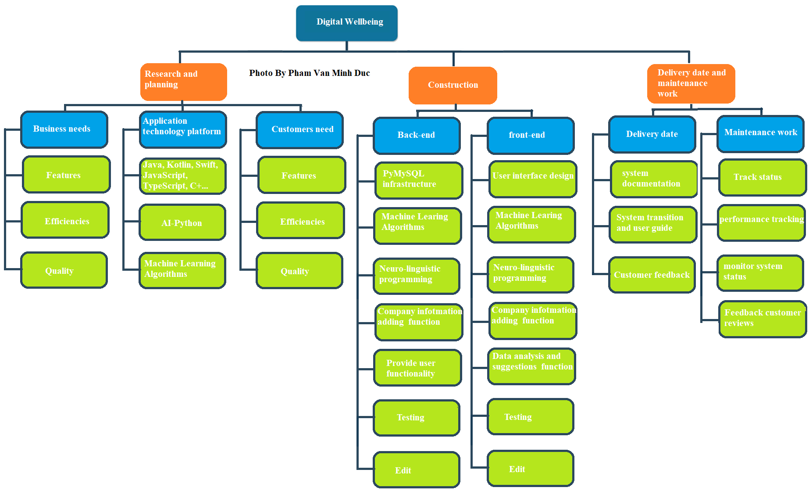  
  
Photo by Pham Van Minh Duc  
  
  
  
  
  
  
  
  
  
  
  
  
  
  
  
  
  
  
  
  
  
  
  
  
  
  
  
Figure 2 Work breakdown structure (WBS)

This is the WBS for the Digital Wellbeing project, which includes 3 job statuses for the project, which clearly show the 3 stages of the project in the development process of the project, which is the Research and Planning, Construction phase as well as the Delivery date and maintenance work. In addition, to be able to assign all tasks clearly too all team members, we will create a Gantt chart as well as the next part of this project I will show and draw Map this as clearly as possible.

#### 2. Progress in the project

##### 2.1. Research and deployment stages

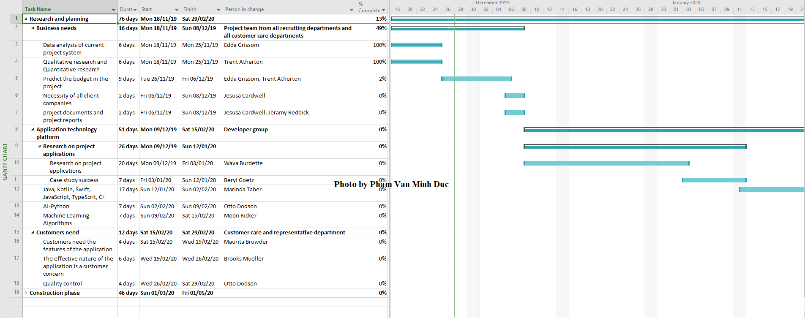  
  
Figure 3 Research and planning in the project

##### 2.2. Construction phase and project development

Figure 4 Construction phase and project development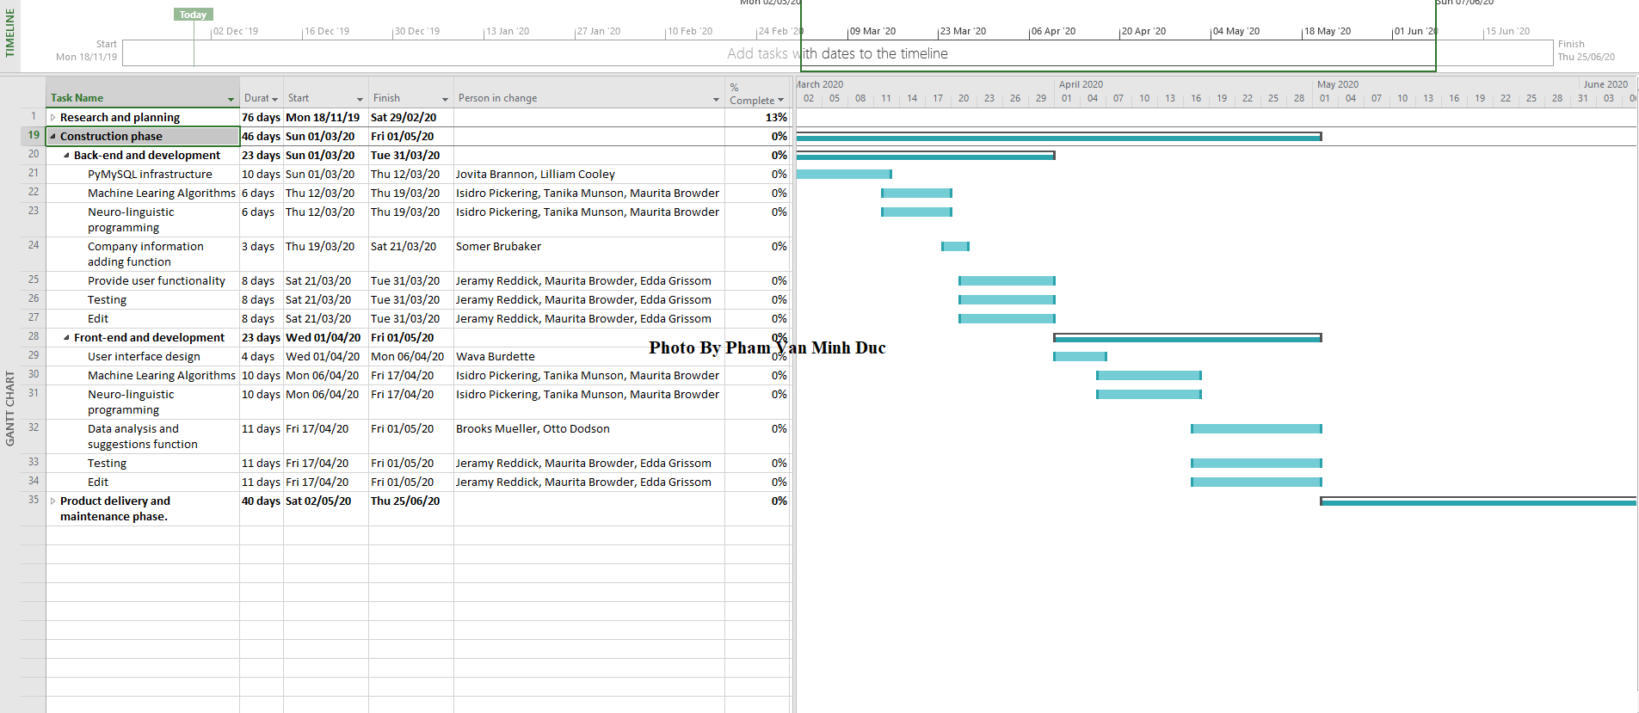

##### 2.3 Product stage and system maintenance

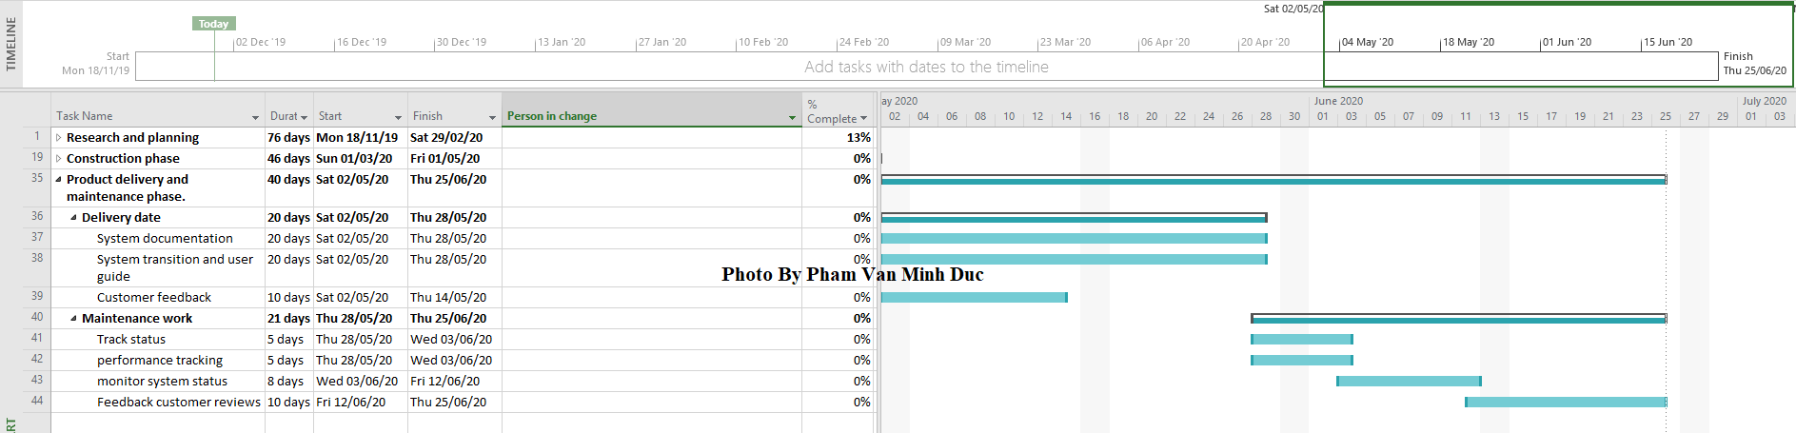Figure 5 Product stage and system maintenance

## P4 and M2 Carry out small-scale research by applying qualitative and quantitative research methods appropriate for meeting project aims and objectives

### I. Research quality in the project

To conduct qualitative research as well as be able to collect all information and collect all data and will create knowledge supporting the development of the Digital Wellbeing Project, a method/technique suitable for project implementation is Joint Application Development (JAD) Interviewing.

JAD is one of the meetings or it can be a workshop that has created a lot of conditions to overcome all problems in the project as well as traditional requirements with which we can agree on ideas in the design and features of the information system as well as very fully all the views of many users as well as other stakeholders in the project.

JAD always interviews all users by forcing all stakeholders in the project to participate in the scheduled meeting as well as it always has a defined length and is always very focused much on all the results as well as it will always be making the right decision. Not only that, JAD's sole purpose is to clarify the goals of the project. In every situation of the Digital Wellbeing project, it is not only all the stakeholders in the project defined in Regulations in the project (page 9) but it always has stakeholders involved in many of the interview processes Interview with JAD, including:

* 10 representatives from various client companies (including many of the companies that Google has previously partnered with as well as new companies eager to partner with Google in the future).
* 5 employees are focused and use their phones and affect their health a lot.
* All members of Digital Wellbeing project development
* Expert from application platform development teams from wellbeing.google.

**Content of everyone's questions:**

* The current user experience of the Digital Wellbeing application (from the perspective of project companies and employees when participating in the project).
* What difficulties in using the application (from the project development team viewpoint).
* How the Digital Wellbeing application can create very positive impacts on users, as well as interest in users (from the perspective of all project leaders as stakeholders in the project and the research and development department as well, eventually all the experts in the project).
* New or old features that users want or can improve the application.

By engaging everyone who can influence or receive impact from the development in the Digital Wellbeing project, from every aspect, including from experts in the current field (background experts) the app platform comes from wellbeing.google) and the app end-user (the client's company and all the employees involved), meet and discuss at the same time, the same place that made the scope, the purpose, and objectives of the project become clear.

### II. Quantitative research in the project

In order to help us conduct quantitative research as well as to be able to collect all the information and collect all the data to help us create knowledge that will assist in the development of the project Digital Wellbeing project, the most appropriate method now is that we have to design and survey online using the Google Form method with the following questionnaire and answer for users:

Figure 6 User survey form table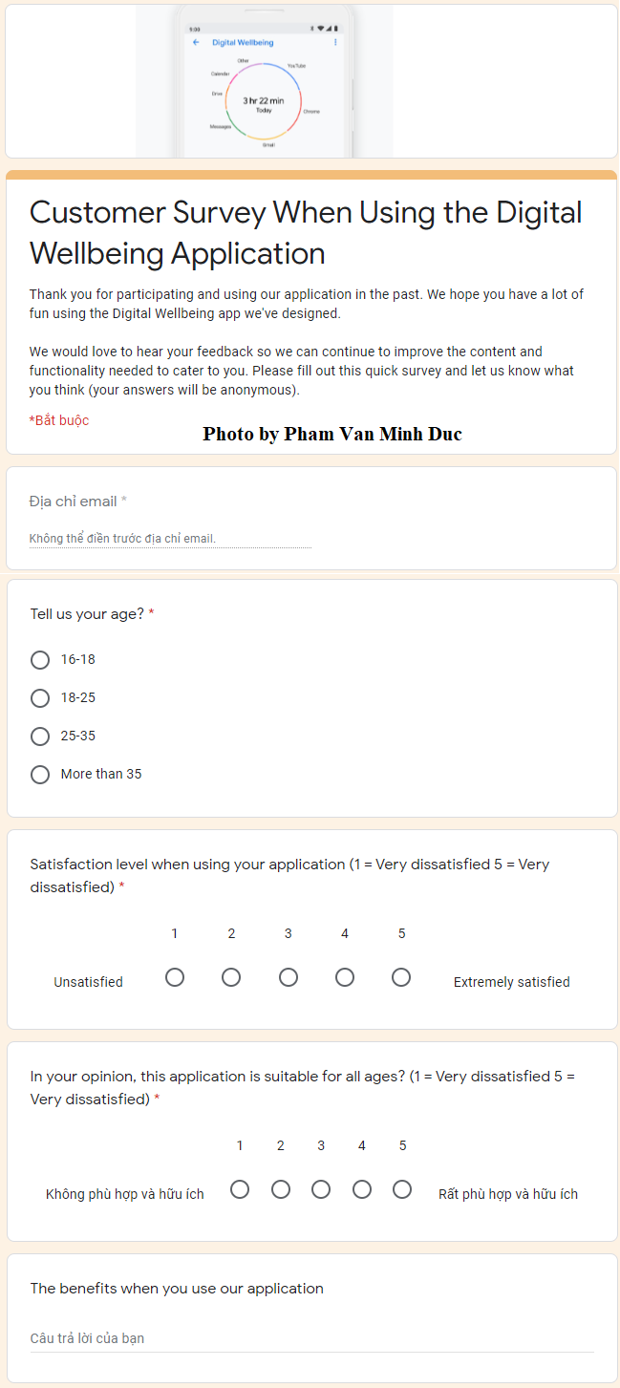

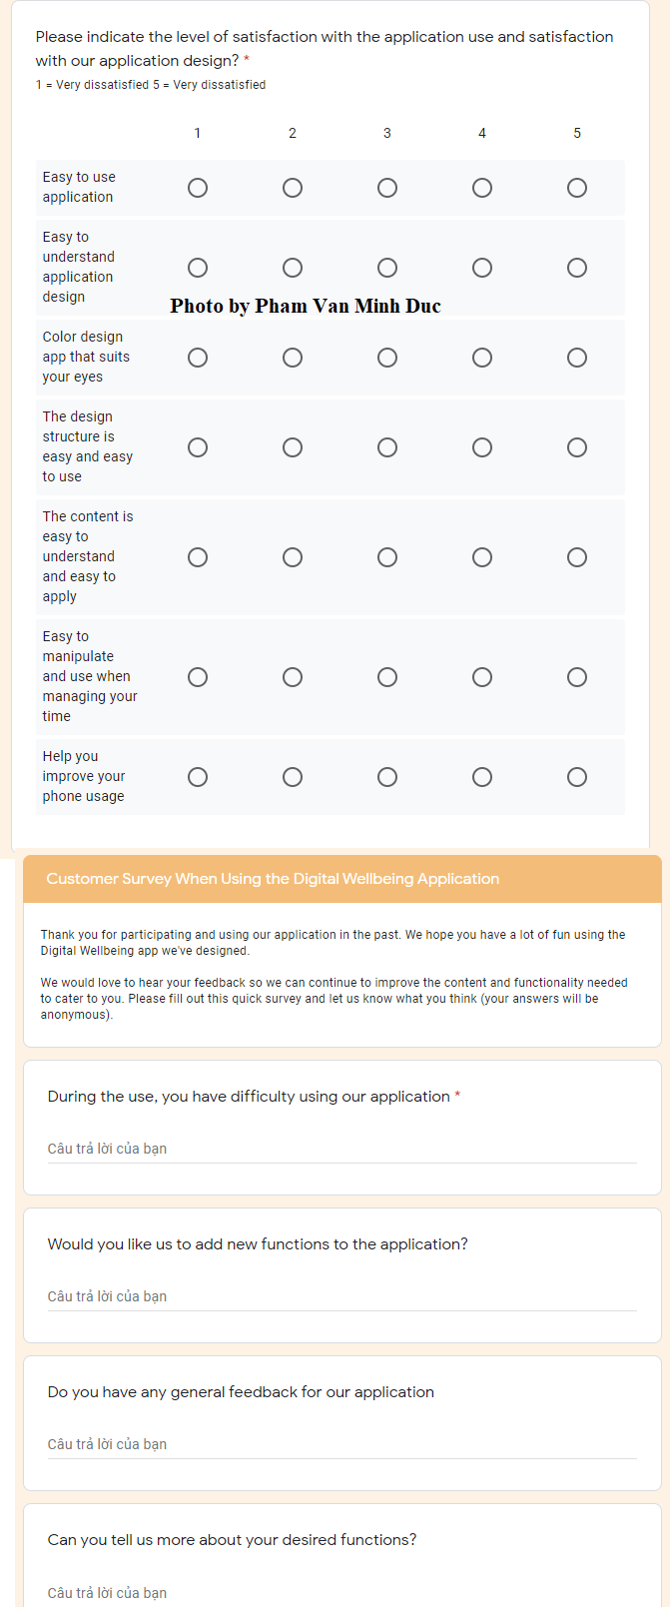

Figure 7 User survey form table

After I created a Google Forms to help me conduct quantitative research and collect all user information, I immediately received a lot of positive user feedback for the project. Our development, the feedback includes:

* The chart calculates the percentage of users of different ages:

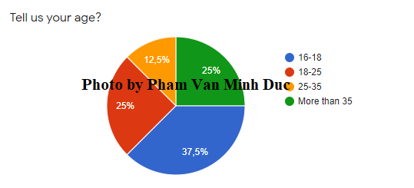

Figure 8 The chart calculates the percentage of ages participating in the survey

* Column chart calculates user satisfaction when using the application (5 point scale):

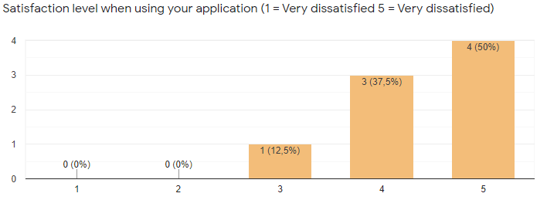

**Photo by Pham Van Minh Duc**

Figure 9 Column chart calculates user satisfaction when using the application

* The graph calculates the satisfaction level with the application usage and the satisfaction with the application design in the project

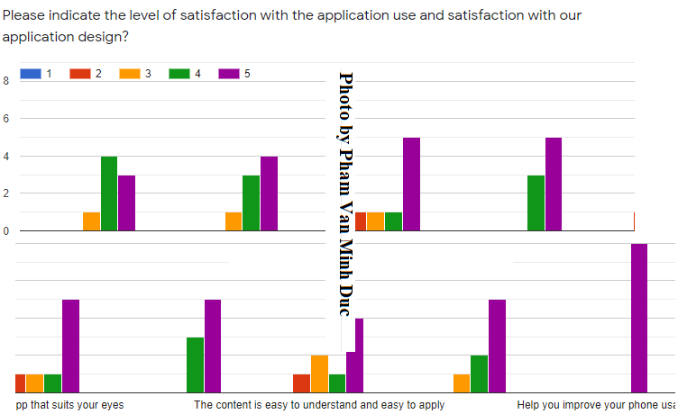

Figure 10 Customer satisfaction level

* User comments to be able to add additional utility functions of the application

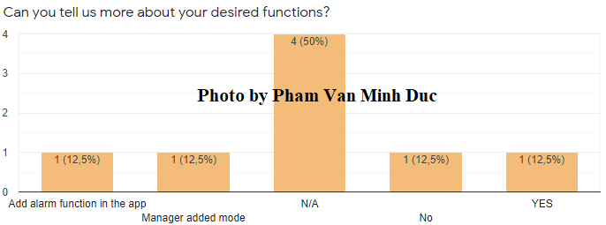

Figure 11 User comments to be able to add additional utility functions of the application

Once we have the questionnaire, and users are very active to spend their own time to answer it, so we will also have very detailed and specific statistics. To better understand the purpose of this questionnaire, the sole purpose of this questionnaire has been fully implemented so that it can be sent to all employees in the company involved. the project, or most specifically, users who have used the Digital Wellbeing app to find and manage their excessive phone usage that affects their health. In addition, with all the data that has been received since the results of this survey, the Research Team was able to have all the information needed to understand them all when they used it. Application, these questions include:

* Average user age when using the app (because we can learn about the average user age so we can share and care more about the user)
* Excessive use of technology or excessive use of the phone affects the health of the user (we learn about this job so that we can have solutions as well as manage time and care, more user-health)
* User feedback when they use the Digital Wellbeing application (in order to improve the Digital Wellbeing application in the fastest and most accurate way, user feedback is very important, because they are the ones using technology)

In brief, when we apply two methods of qualitative and quantitative research, the results we can collect will be one of the main and most important components to creating a great work of the Digital Wellbeing project. In addition, we will have the goal as well as the purpose of the project, which we will define a lot more clearly.

# Bibliography

Baker, H. (n.d.). *Best Project Management Practices for Successful Project Managers*. Retrieved from http://www.harrybakertraining.com: http://www.harrybakertraining.com/best-project-management-practices-successful-project-managers/

Billah, S. (N/A, N/A N/A). *Managing a successful business project on Implementing CSR activities*. Retrieved N/A N/A, N/A, from https://www.academia.edu: https://www.academia.edu/35876489/Managing_a_successful_business_project_on_Implementing_CSR_activities